Заключительный урок по теме « Food and Refreshments» в 6 классе (учебник Spotlight)
Учитель английского языка, Морозова Тамара Александровна
Обучающая цель:- обобщить языковой материал по теме « Еда»
Развивающая цель: - развивать умения говорить о традиционной английской кухне и соотносить её с русской кухней
Воспитательная цель:- воспитывать культуру питания как составляющую здорового образа жизни, воспитывать уважение к традициям национальной кухни
Задачи урока: - развивать умение выборочно понимать на слух необходимую информацию без опоры и с опорой на текст
-повторить активную лексику модуля
-развивать умение монологической речи на основе прочитанного, умение составления кулинарного рецепта
Оснащение урока: - аудиозапись песни и текст песни, учебник «Английский в фокусе», раздаточный материал с заданием, детские работы в виде презентаций в программе Power Point
или в виде плакатов, картинки с изображением продуктов питания
Ход урока
1.Организационный момент. Приветствие, сообщение темы урока.
Good morning, dear girls and boys! Glad to see you here. I hope you are Ok today. I’m OK too.
Today we are going to remember everything we discussed at the previous classes and speak about English and Russian food, about your delicious recipes. Let `s start with a short poem.
2.Фонетическая зарядка
I am a hearty eater
And so I always eat
All food that isn’t bitter
All food that’s good and sweet.
Режим работы T-Cl-P1,P2,P3
3.Речевая подготовка
-Are you a good eater? What do you like to eat: meat, fish, dairy products or sweet things? Are sweet things good for your health? What healthy food do you remember?
-Now I am going to show you some pictures. Express your attitude. Use the model:- I like it. It is delicious./ I don’t like (hate) it. It is awful. It contains (doesn’t contain) vitamins. You may use the words:
Tasty, terrific, salty, bitter, healthy, horrible, fantastic, disgusting , fibre, iron, vitamin, potassium, calcium, protein.
(опорные слова выписаны или спроектированы на доску и дети повторяют их за учителем хором и индивидуально)
Different people eat different food. Do you remember the British traditional food? Let us do a small test.
You are divided into three groups. Do the test in groups. Who will be the first?
TEST
1. The English have … for breakfast. A –cereal or toast with tea B- spaghetti and coffee
2. Sunday roast is… A- roast chicken with potatoes and gravy b- roast beef with potatoes, vegetables and gravy
3. The English have… for dessert A- home made puddings, apple pie and trifle B- fruit salad and biscuits
4. A packed lunch is… A- a sandwich, a packet of crisps, a piece of fruit and drink B- salad, shepherd’s pie, juice
-And what about Russian traditional food? Name some of them.
4. Аудирование.
Now I want you to listen to the song.1. What products are mentioned here?( слушают без опоры на текст) Now open your textbooks on page SS3 and look at the text.2. Listen to the song again and tick the ingredients in the picture.
3. Read the song and name three cooking verbs ( fry, cook, bake).What do they mean?
4. What type of meal is the singer describing? 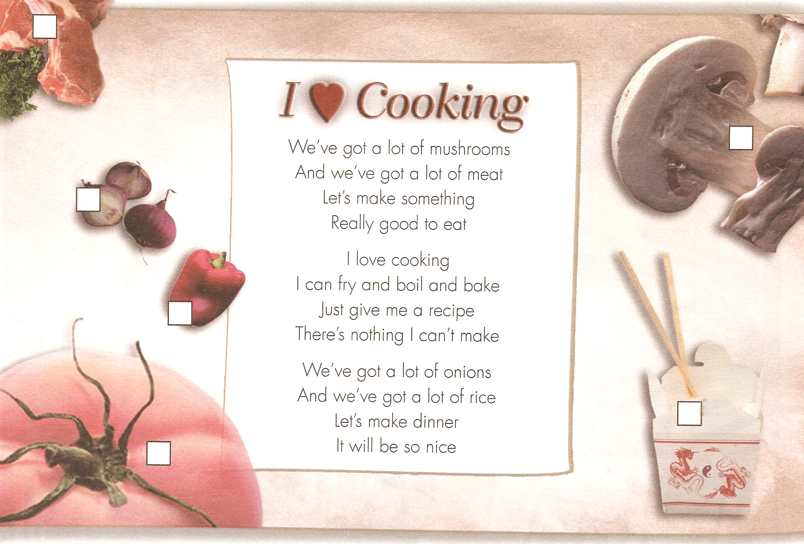

5. And you? Do you like cooking? Can you cook? Let us listen to your delicious recipes.( Защита проектов в виде презентаций. Одна презентация от группы).
6. Контроль домашнего задания
Look at this picture. What can you see here? Quite right! Of course, mushrooms.
Do you like eating them? Are they good for your health? Who mostly likes to eat them? Of course Russians! Quite so.
Let us see what you have found about them. (page 11, Spotlight on Russia)
1.What is the best translation for –go hunting for mushrooms
- bake mushrooms with sour cream
- fry with butter
- cook as a main dish
- mix with cheese
Read them after me. Find them in the text. Read the sentence out. Translate it.
2. Answer the questions.1. When do Russian people go hunting?
2. What do they do with them?
3. Tell us some words about mushrooms and how you use them at home.( краткое изложение прочитанного текста).
7. I like your work today. It is time for us to have a small competition between the groups.
1. The first task is to do the crossword.
2. Underline the odd word.
3. Write the correct word.
Материал заданий для групп взят из раздела учебника Progress Check.
8. Подведение итогов урока, выставление оценок.
I liked your answers today. I give you excellent and good marks. But some of you will get a certificate of “ A GOOD COOK” and “ THE BEST MUSHROOM HUNTER”. Thank you. Good bye.

